1. **In yaml data is in 3 main format.**

**Key-value pair**

**Array**

**Dictionary**

1. **Key-value pair**

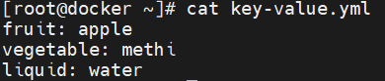

1. **Array**

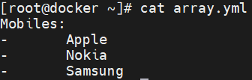

1. **Dictionary**

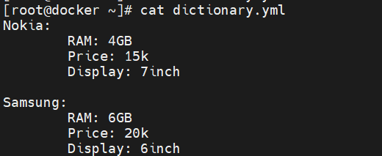

1. **Dictionary in Dictionary**

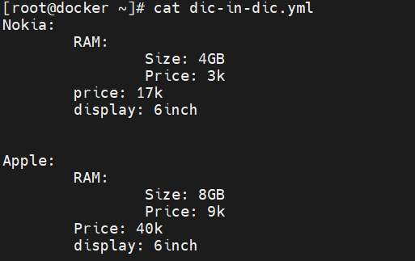

1. **List of dictionary**

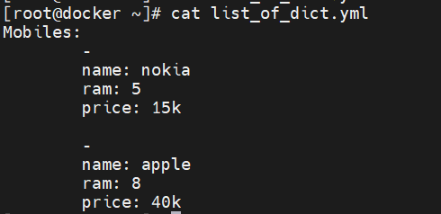

**Note: Yaml is superset of the json. That is why you can easily convert yaml to json.**